PROPS

Props is a special keyword in React that stands for properties and is being used to pass data from one component to another and mostly from parent component to child component. We can say props is a data carrier or a means to transport data.

I hope you are familiar with the JavaScript function. Most of the time, functions with parameters are smart and they can take dynamic data likewise props is a way we pass data or parameter to a component. Let's see the difference between a function and a component.

// function syntax

const getUserInfo = (firstName, lastName, country) => {

return `${firstName} ${lastName}. Lives in ${country}.`

}

// calling a functons

getUserInfo('Asabeneh', 'Yeteyeh', 'Finland')

//component syntax

// User component, component should start with an uppercase

const User = (props) => {

return (

<div>

<h1>

{props.firstName}

{props.lastName}

</h1>

<small>{props.country}</small>

</div>

)

}

// calling or instantiating a component, this component has three properties and we call them props:firstName, lastName, country

<User firstName = 'Asabeneh', lastName='Yetayeh' country = 'Finland' />

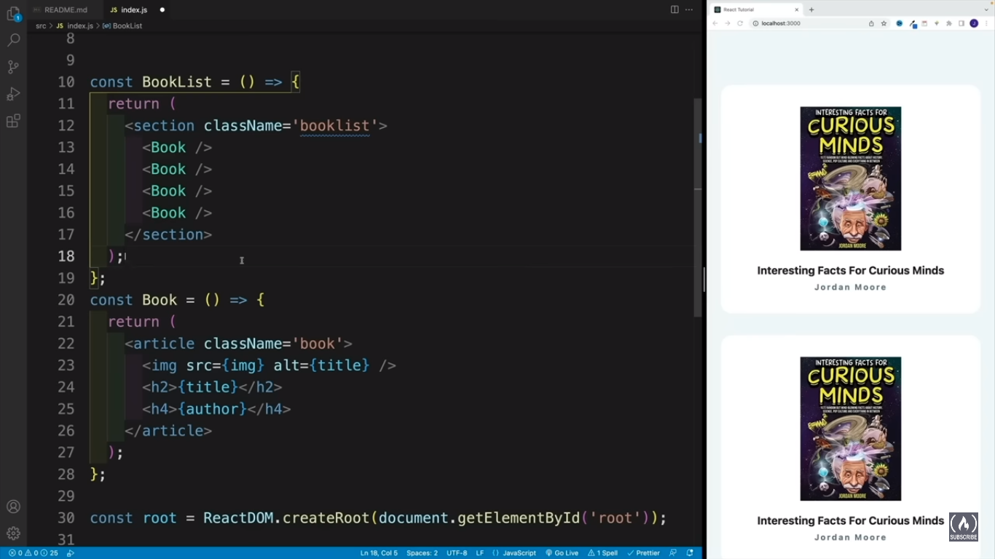

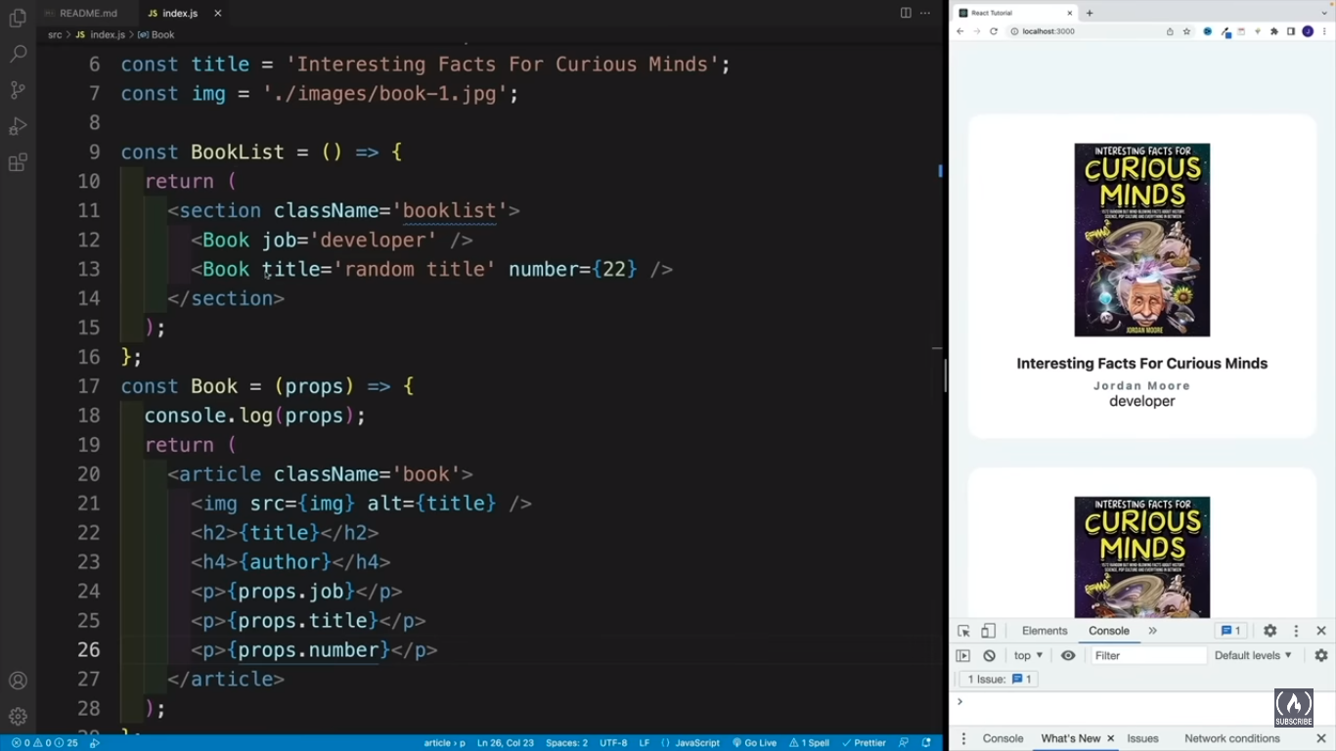

In the previous section, we injected data as follows and today we will change these data to props.

const welcome = 'Welcome to 30 Days Of React'

const title = 'Getting Started React'

const subtitle = 'JavaScript Library'

const author = {

firstName: 'Asabeneh',

lastName: 'Yetayeh',

}

const date = 'Oct 4, 2020'

// Header Component

const Header = () => (

<header>

<div className='header-wrapper'>

<h1>{welcome}</h1>

<h2>{title}</h2>

<h3>{subtitle}</h3>

<p>

{author.firstName} {author.lastName}

</p>

<small>{date}</small>

</div>

</header>

)

**Components and Props**

Components let you split the UI into independent, reusable pieces, and think about each piece in isolation. This page provides an introduction to the idea of components. You can find a detailed component API reference here.

Conceptually, components are like JavaScript functions. They accept arbitrary inputs (called “props”) and return React elements describing what should appear on the screen.

**Function and Class Components**

The simplest way to define a component is to write a JavaScript function:

function Welcome(props) {

return <h1>Hello, {props.name}</h1>;

}

This function is a valid React component because it accepts a single “props” (which stands for properties) object argument with data and returns a React element. We call such components “function components” because they are literally JavaScript functions.

You can also use an [ES6 class](https://developer.mozilla.org/en/docs/Web/JavaScript/Reference/Classes) to define a component:

class Welcome extends React.Component {

render() {

return <h1>Hello, {this.props.name}</h1>;

}

}

The above two components are equivalent from React’s point of view.

Function and Class components both have some additional features that we will discuss in the [next sections](https://legacy.reactjs.org/docs/state-and-lifecycle.html).

**Rendering a Component**

Previously, we only encountered React elements that represent DOM tags:

const element = <div />;

However, elements can also represent user-defined components:

const element = <Welcome name="Sara" />;

When React sees an element representing a user-defined component, it passes JSX attributes and children to this component as a single object. We call this object “props”.

For example, this code renders “Hello, Sara” on the page:

function Welcome(props) { return <h1>Hello, {props.name}</h1>;

}

const root = ReactDOM.createRoot(document.getElementById('root'));

const element = <Welcome name="Sara" />;root.render(element);

**Composing Components**

Components can refer to other components in their output. This lets us use the same component abstraction for any level of detail. A button, a form, a dialog, a screen: in React apps, all those are commonly expressed as components.

For example, we can create an App component that renders Welcome many times:

function Welcome(props) {

return <h1>Hello, {props.name}</h1>;

}

function App() {

return (

<div>

<Welcome name="Sara" /> <Welcome name="Cahal" /> <Welcome name="Edite" /> </div>

);

}

Typically, new React apps have a single App component at the very top. However, if you integrate React into an existing app, you might start bottom-up with a small component like Button and gradually work your way to the top of the view hierarchy.

**Extracting Components**

Don’t be afraid to split components into smaller components.

For example, consider this Comment component:

function Comment(props) {

return (

<div className="Comment">

<div className="UserInfo">

<img className="Avatar"

src={props.author.avatarUrl}

alt={props.author.name}

/>

<div className="UserInfo-name">

{props.author.name}

</div>

</div>

<div className="Comment-text">

{props.text}

</div>

<div className="Comment-date">

{formatDate(props.date)}

</div>

</div>

);

}

It accepts author (an object), text (a string), and date (a date) as props, and describes a comment on a social media website.

This component can be tricky to change because of all the nesting, and it is also hard to reuse individual parts of it. Let’s extract a few components from it.

First, we will extract Avatar:

function Avatar(props) {

return (

<img className="Avatar" src={props.user.avatarUrl} alt={props.user.name} /> );

}

The Avatar doesn’t need to know that it is being rendered inside a Comment. This is why we have given its prop a more generic name: user rather than author.

We recommend naming props from the component’s own point of view rather than the context in which it is being used.

We can now simplify Comment a tiny bit:

function Comment(props) {

return (

<div className="Comment">

<div className="UserInfo">

<Avatar user={props.author} /> <div className="UserInfo-name">

{props.author.name}

</div>

</div>

<div className="Comment-text">

{props.text}

</div>

<div className="Comment-date">

{formatDate(props.date)}

</div>

</div>

);

}

Next, we will extract a UserInfo component that renders an Avatar next to the user’s name:

function UserInfo(props) {

return (

<div className="UserInfo"> <Avatar user={props.user} /> <div className="UserInfo-name"> {props.user.name} </div> </div> );

}

This lets us simplify Comment even further:

function Comment(props) {

return (

<div className="Comment">

<UserInfo user={props.author} /> <div className="Comment-text">

{props.text}

</div>

<div className="Comment-date">

{formatDate(props.date)}

</div>

</div>

);

}

Extracting components might seem like grunt work at first, but having a palette of reusable components pays off in larger apps. A good rule of thumb is that if a part of your UI is used several times (Button, Panel, Avatar), or is complex enough on its own (App, FeedStory, Comment), it is a good candidate to be extracted to a separate component.

**Props are Read-Only**

Whether you declare a component [as a function or a class](https://legacy.reactjs.org/docs/components-and-props.html#function-and-class-components), it must never modify its own props. Consider this sum function:

function sum(a, b) {

return a + b;

}

Such functions are called [“pure”](https://en.wikipedia.org/wiki/Pure_function) because they do not attempt to change their inputs, and always return the same result for the same inputs.

In contrast, this function is impure because it changes its own input:

function withdraw(account, amount) {

account.total -= amount;

}

React is pretty flexible but it has a single strict rule:

**All React components must act like pure functions with respect to their props.**

Of course, application UIs are dynamic and change over time. In the [next section](https://legacy.reactjs.org/docs/state-and-lifecycle.html), we will introduce a new concept of “state”. State allows React components to change their output over time in response to user actions, network responses, and anything else, without violating this rule.

**Examples**

**Props object**

React props is an object which you get instantly when you create a React component. Before we pass properties to the component, let's check what do we get in the props object.

import React from 'react'

import ReactDOM from 'react-dom'

// Header Component

const Header = (props) => {

console.log(props) // empty object, {}

return (

<header>

<div className='header-wrapper'>

<h1>{welcome}</h1>

<h2>{title}</h2>

<h3>{subtitle}</h3>

<p>

{author.firstName} {author.lastName}

</p>

<small>{date}</small>

</div>

</header>

)

}

// The App, or the parent or the container component

// Functional Component

const App = () => {

return (

<div className='app'>

<Header />

</div>

)

}

const rootElement = document.getElementById('root')

ReactDOM.render(<App />, rootElement)

In the above console.log(props), you would get an empty object({}). That means if you do not pass any attributes or properties when you instantiate the component, the props will be empty otherwise it will be populated with the data you passed as attributes and the proper name of these attributes are props.

Let's start with a simple example. In the example below, the welcome string has been passed as props in the Header components.

import React from 'react'

import ReactDOM from 'react-dom'

// Header Component

const Header = (props) => {

console.log(props) // {welcome:'Welcome to 30 Days Of React'}

return (

<header>

<div className='header-wrapper'>

<h1>{props.welcome}</h1>

</div>

</header>

)

}

// The App, or the parent or the container component

// Functional Component

const App = () => {

return (

<div className='app'>

<Header welcome='Welcome to 30 Days Of React' />

</div>

)

}

const rootElement = document.getElementById('root')

ReactDOM.render(<App />, rootElement)

Now, when you do console.log(props) you should get the following object, that means the welcome property we passed to the Header component can be found inside the props object.

{

welcome: 'Welcome to 30 Days Of React'

}

As you can see in the above code, we passed only single props to Header component, the welcome props. A component can have one or many props. Props could be different data types. It could be a string, number, boolean, array, object or a function. We will cover different kind of props in the next sections.

**Different data type props**

**String props type**

The data type of the props we pass an attribute to the component is a string.

import React from 'react'

import ReactDOM from 'react-dom'

// Header Component

const Header = (props) => {

console.log(props)

return (

<header>

<div className='header-wrapper'>

<h1>{props.welcome}</h1>

<h2>{props.title}</h2>

<h3>{props.subtitle}</h3>

<p>

{props.firstName} {props.lastName}

</p>

<small>{props.date}</small>

</div>

</header>

)

}

// The App, or the parent or the container component

// Functional Component

const App = () => (

<div className='app'>

<Header

welcome='Welcome to 30 Days Of React'

title='Getting Started React'

subtitle='JavaScript Library'

firstName='Asabeneh'

lastName='Yetayeh'

date='Oct 4, 2020'

/>

</div>

)

const rootElement = document.getElementById('root')

ReactDOM.render(<App />, rootElement)

If you check on the browser console, you will get the following object.

{

firstName: "Asabeneh",

lastName: "Yetayeh",

date: "Oct 4, 2020"

subtitle: "JavaScript Library"

title: "Getting Started React"

welcome: "Welcome to 30 Days Of React"

}

Since you are a JavaScript ninja by now, you know what do do with this object.

As you can see from the above example, the value of the props are written statically. However, if we want to apply some logic it is hard to implement with statically written data, so it will be better to use a variable as props. Let's see the following example:

import React from 'react'

import ReactDOM from 'react-dom'

// Header Component

const Header = (props) => (

<header>

<div className='header-wrapper'>

<h1>{props.welcome}</h1>

<h2>{props.title}</h2>

<h3>{props.subtitle}</h3>

<p>

{props.firstName} {props.lastName}

</p>

<small>{props.date}</small>

</div>

</header>

)

// The App, or the parent or the container component

// Functional Component

const App = () => {

const welcome = 'Welcome to 30 Days Of React'

const title = 'Getting Started React'

const subtitle = 'JavaScript Library'

const firstName = 'Asabeneh'

const lastName = 'Yetayeh'

const date = 'Oct 4, 2020'

return (

<div className='app'>

<Header

welcome={welcome}

title={title}

subtitle={subtitle}

firstName={firstName}

lastName={lastName}

date={date}

/>

</div>

)

}

const rootElement = document.getElementById('root')

ReactDOM.render(<App />, rootElement)

**Number props type**

Let's use a number props to a component

import React from 'react'

import ReactDOM from 'react-dom'

const Age = (props) => <div>The person is {props.age} years old.</div>

const Weight = (props) => (

<p>The weight of the object on earth is {props.weight} N.</p>

)

// The App, or the parent or the container component

// Functional Component

const App = () => {

let currentYear = 2020

let birthYear = 1820

const age = currentYear - birthYear

const gravity = 9.81

const mass = 75

return (

<div className='app'>

<Age age={age} />

<Weight weight={gravity * mass} />

</div>

)

}

const rootElement = document.getElementById('root')

ReactDOM.render(<App />, rootElement)

**Boolean props type**

We can pass boolean data types to a React component.

import React from 'react'

import ReactDOM from 'react-dom'

const Status = (props) => {

// ternary operator to check the status of the person

let status = props.status ? 'Old enough to drive' : 'Too young for driving'

return <p>{status}</p>

}

// The App, or the parent or the container component

// Functional Component

const App = () => {

let currentYear = 2020

let birthYear = 2015

const age = currentYear - birthYear // 15 years

let status = age >= 18

return (

<div className='app'>

<Status status={status} />

</div>

)

}

const rootElement = document.getElementById('root')

ReactDOM.render(<App />, rootElement)

**Array props type**

In programming arrays and objects are the most frequently used data structure to solve different problems and store data in a more structured way. Therefore, we encounter data in the form of an array quite often. Let's pass an array as props to a component

import React from 'react'

import ReactDOM from 'react-dom'

const Skills = (props) => <ul>{props.skills}</ul>

const App = () => (

<div className='app'>

<Skills skills={['HTML', 'CSS', 'JavaScript']} />

</div>

)

const rootElement = document.getElementById('root')

ReactDOM.render(<App />, rootElement)

If you see the result on the browser, the skills elements needs formatting. Therefore before we render, it should have some elements between each skill. To modify the array and to add a li element we can use map method. You should be very familiar with the functional programming map, filter and reduce to feel good at React if not please go back to day 1 JavaScript refresher. Let's apply map to modify the array.

import React from 'react'

import ReactDOM from 'react-dom'

// Skills Component

const Skills = (props) => {

// modifying the skills array

const skillList = props.skills.map((skill) => <li>{skill}</li>)

return <ul>{skillList}</ul>

}

const App = () => (

<div className='app'>

<Skills skills={['HTML', 'CSS', 'JavaScript']} />

</div>

)

const rootElement = document.getElementById('root')

ReactDOM.render(<App />, rootElement)

We will go in-depth about list and map in other sections. Now, let's see an object as a props.

**Object props type**

We may pass an object as props to a React component. Let's see an example. We can change the previous Header props to object. For the time being let's change a few properties for better understanding.

import React from 'react'

import ReactDOM from 'react-dom'

// Header Component

const Header = (props) => {

return (

<header>

<div className='header-wrapper'>

<h1>{props.data.welcome}</h1>

<h2>{props.data.title}</h2>

<h3>{props.data.subtitle}</h3>

</div>

</header>

)

}

// The App, or the parent or the container component

// Functional Component

const App = () => {

const data = {

welcome: 'Welcome to 30 Days Of React',

title: 'Getting Started React',

subtitle: 'JavaScript Library',

}

return (

<div className='app'>

<Header data={data} />

</div>

)

}

const rootElement = document.getElementById('root')

// we render the JSX element using the ReactDOM package

ReactDOM.render(<App />, rootElement)

Now, let's change all the previous Header properties to an object.

import React from 'react'

import ReactDOM from 'react-dom'

const showDate = (time) => {

const months = [

'January',

'February',

'March',

'April',

'May',

'June',

'July',

'August',

'September',

'October',

'November',

'December',

]

const month = months[time.getMonth()].slice(0, 3)

const year = time.getFullYear()

const date = time.getDate()

return ` ${month} ${date}, ${year}`

}

// Header Component

const Header = (props) => {

return (

<header>

<div className='header-wrapper'>

<h1>{props.data.welcome}</h1>

<h2>{props.data.title}</h2>

<h3>{props.data.subtitle}</h3>

<p>

{props.data.author.firstName} {props.data.author.lastName}

</p>

<small>{showDate(props.data.date)}</small>

</div>

</header>

)

}

// The App, or the parent or the container component

// Functional Component

const App = () => {

const data = {

welcome: 'Welcome to 30 Days Of React',

title: 'Getting Started React',

subtitle: 'JavaScript Library',

author: {

firstName: 'Asabeneh',

lastName: 'Yetayeh',

},

date: new Date(), // date needs to be formatted to a human readable format

}

return (

<div className='app'>

<Header data={data} />

</div>

)

}

const rootElement = document.getElementById('root')

ReactDOM.render(<App />, rootElement)

When we use an object as props we usually destructure the data to access the values. Destructuring makes our code easy to read. We will soon see the destructuring of props but before that let's see function as props for a React component.

**Function prop types**

We can pass a function as props type to a React component. Let's see some examples

import React from 'react'

import ReactDOM from 'react-dom'

// A button component

const Button = (props) => <button onClick={props.onClick}>{props.text}</button>

// The App, or the parent or the container component

// Functional Component

const App = () => {

const sayHi = () => {

alert('Hi')

}

return (

<div className='app'>

<Button text='Say Hi' onClick={sayHi} />

</div>

)

}

const rootElement = document.getElementById('root')

// we render the JSX element using the ReactDOM package

ReactDOM.render(<App />, rootElement)

Even we can write a function inside the curly bracket

import React from 'react'

import ReactDOM from 'react-dom'

// A button component

const Button = (props) => <button onClick={props.onClick}>{props.text}</button>

// The App, or the parent or the container component

// Functional Component

const App = () => {

return (

<div className='app'>

<Button text='Say Hi' onClick={() => alert('Hi')} />

</div>

)

}

const rootElement = document.getElementById('root')

// we render the JSX element using the ReactDOM package

ReactDOM.render(<App />, rootElement)

Now, lets implement different functions as props

import React from 'react'

import ReactDOM from 'react-dom'

// A button component

const Button = (props) => <button onClick={props.onClick}>{props.text}</button>

// The App, or the parent or the container component

// Functional Component

const App = () => {

const greetPeople = () => {

alert('Welcome to 30 Days Of React Challenge, 2020')

}

return (

<div className='app'>

<Button text='Greet People' onClick={greetPeople} />

<Button text='Show Time' onClick={() => alert(new Date())} />

</div>

)

}

const rootElement = document.getElementById('root')

ReactDOM.render(<App />, rootElement)

In the above example, onClick is a props to hold the greetPeople function. HTML has onclick, onmouseover, onhover, onkeypress and etc event handlers. In React, these handlers are in camelCase. For instance onClick, onMouseOver, onKeyPress etc. We will cover events in React in detail in other section.

Let's see some more functions as props to give a clear understanding how to handle function as props in a React component.

This component shows month, date and year as an alert box.

import React from 'react'

import ReactDOM from 'react-dom'

// Function to display time in Mon date, year format eg Oct 4, 2020

const showDate = (time) => {

const months = [

'January',

'February',

'March',

'April',

'May',

'June',

'July',

'August',

'September',

'October',

'November',

'December',

]

const month = months[time.getMonth()].slice(0, 3)

const year = time.getFullYear()

const date = time.getDate()

return ` ${month} ${date}, ${year}`

}

// A button component

const Button = (props) => <button onClick={props.onClick}>{props.text}</button>

// The App, or the parent or the container component

// Functional Component

const App = () => {

const handleTime = () => {

alert(showDate(new Date()))

}

const greetPeople = () => {

alert('Welcome to 30 Days Of React Challenge, 2020')

}

return (

<div className='app'>

<Button text='show time' onClick={handleTime} />

<Button text='Greet People' onClick={greetPeople} />

</div>

)

}

const rootElement = document.getElementById('root')

ReactDOM.render(<App />, rootElement)

**Destructuring props**

By now, I believe you are a JavaScript ninja and you know about destructing arrays and objects. Destructuring code to some extent makes easy to read. Let us destructure the props in Header component. Everything we passed as props is stored in props object. Therefore, props is an object and we can destructure the properties. Let's destructure some of the props we wrote in object props example. We can destructure in many ways:

1. Step by step destructuring

import React from 'react'

import ReactDOM from 'react-dom'

const showDate = (time) => {

const months = [

'January',

'February',

'March',

'April',

'May',

'June',

'July',

'August',

'September',

'October',

'November',

'December',

]

const month = months[time.getMonth()].slice(0, 3)

const year = time.getFullYear()

const date = time.getDate()

return ` ${month} ${date}, ${year}`

}

// Header Component

const Header = (props) => {

const data = props.data

const { welcome, title, subtitle, author, date } = data

const { firstName, lastName } = author

return (

<header>

<div className='header-wrapper'>

<h1>{welcome}</h1>

<h2>{title}</h2>

<h3>{subtitle}</h3>

<p>

{firstName} {lastName}

</p>

<small>{showDate(date)}</small>

</div>

</header>

)

}

// The App, or the parent or the container component

// Functional Component

const App = () => {

const data = {

welcome: 'Welcome to 30 Days Of React',

title: 'Getting Started React',

subtitle: 'JavaScript Library',

author: {

firstName: 'Asabeneh',

lastName: 'Yetayeh',

},

date: new Date(),

}

return (

<div className='app'>

<Header data={data} />

</div>

)

}

const rootElement = document.getElementById('root')

// we render the JSX element using the ReactDOM package

ReactDOM.render(<App />, rootElement)

1. Destructuring in one line

import React from 'react'

import ReactDOM from 'react-dom'

const showDate = (time) => {

const months = [

'January',

'February',

'March',

'April',

'May',

'June',

'July',

'August',

'September',

'October',

'November',

'December',

]

const month = months[time.getMonth()].slice(0, 3)

const year = time.getFullYear()

const date = time.getDate()

return ` ${month} ${date}, ${year}`

}

// Header Component

const Header = (props) => {

const data = props.data

const {

welcome,

title,

subtitle,

author: { firstName, lastName },

date,

} = data

return (

<header>

<div className='header-wrapper'>

<h1>{welcome}</h1>

<h2>{title}</h2>

<h3>{subtitle}</h3>

<p>

{firstName} {lastName}

</p>

<small>{showDate(date)}</small>

</div>

</header>

)

}

// The App, or the parent or the container component

// Functional Component

const App = () => {

const data = {

welcome: 'Welcome to 30 Days Of React',

title: 'Getting Started React',

subtitle: 'JavaScript Library',

author: {

firstName: 'Asabeneh',

lastName: 'Yetayeh',

},

date: new Date(),

}

return (

<div className='app'>

<Header data={data} />

</div>

)

}

const rootElement = document.getElementById('root')

ReactDOM.render(<App />, rootElement)

1. Destructuring the props inside the parenthesis

import React from 'react'

import ReactDOM from 'react-dom'

const showDate = (time) => {

const months = [

'January',

'February',

'March',

'April',

'May',

'June',

'July',

'August',

'September',

'October',

'November',

'December',

]

const month = months[time.getMonth()].slice(0, 3)

const year = time.getFullYear()

const date = time.getDate()

return ` ${month} ${date}, ${year}`

}

// Header Component

const Header = ({

data: {

welcome,

title,

subtitle,

author: { firstName, lastName },

date,

},

}) => {

return (

<header>

<div className='header-wrapper'>

<h1>{welcome}</h1>

<h2>{title}</h2>

<h3>{subtitle}</h3>

<p>

{firstName} {lastName}

</p>

<small>{showDate(date)}</small>

</div>

</header>

)

}

// The App, or the parent or the container component

// Functional Component

const App = () => {

const data = {

welcome: 'Welcome to 30 Days Of React',

title: 'Getting Started React',

subtitle: 'JavaScript Library',

author: {

firstName: 'Asabeneh',

lastName: 'Yetayeh',

},

date: new Date(),

}

return (

<div className='app'>

<Header data={data} />

</div>

)

}

const rootElement = document.getElementById('root')

ReactDOM.render(<App />, rootElement)

Now, let's destructure all the components we had and assemble them together. We pass props from one component to another typically from parent to a child component. For instance in the Main component techs, user, greetPeople and handleTime props have been passed from the parent component Main to child components TechList and UserCard. Below, you will get all the codes destructured and cleaned.

import React from 'react'

import ReactDOM from 'react-dom'

import asabenehImage from './images/asabeneh.jpg'

// Fuction to show month date year

const showDate = (time) => {

const months = [

'January',

'February',

'March',

'April',

'May',

'June',

'July',

'August',

'September',

'October',

'November',

'December',

]

const month = months[time.getMonth()].slice(0, 3)

const year = time.getFullYear()

const date = time.getDate()

return ` ${month} ${date}, ${year}`

}

// Header Component

const Header = ({

data: {

welcome,

title,

subtitle,

author: { firstName, lastName },

date,

},

}) => {

return (

<header>

<div className='header-wrapper'>

<h1>{welcome}</h1>

<h2>{title}</h2>

<h3>{subtitle}</h3>

<p>

{firstName} {lastName}

</p>

<small>{showDate(date)}</small>

</div>

</header>

)

}

// TechList Component

const TechList = ({ techs }) => {

const techList = techs.map((tech) => <li key={tech}>{tech}</li>)

return techList

}

// User Card Component

const UserCard = ({ user: { firstName, lastName, image } }) => (

<div className='user-card'>

<img src={image} alt={firstName} />

<h2>

{firstName}

{lastName}

</h2>

</div>

)

// A button component

const Button = ({ text, onClick, style }) => (

<button style={style} onClick={onClick}>

{text}

</button>

)

// CSS styles in JavaScript Object

const buttonStyles = {

backgroundColor: '#61dbfb',

padding: 10,

border: 'none',

borderRadius: 5,

margin: 3,

cursor: 'pointer',

fontSize: 18,

color: 'white',

}

// Main Component

const Main = ({ user, techs, greetPeople, handleTime }) => (

<main>

<div className='main-wrapper'>

<p>Prerequisite to get started react.js:</p>

<ul>

<TechList techs={techs} />

</ul>

<UserCard user={user} />

<Button text='Greet People' onClick={greetPeople} style={buttonStyles} />

<Button text='Show Time' onClick={handleTime} style={buttonStyles} />

</div>

</main>

)

// Footer Component

const Footer = ({ copyRight }) => (

<footer>

<div className='footer-wrapper'>

<p>Copyright {copyRight.getFullYear()}</p>

</div>

</footer>

)

// The App, or the parent or the container component

// Functional Component

const App = () => {

const data = {

welcome: 'Welcome to 30 Days Of React',

title: 'Getting Started React',

subtitle: 'JavaScript Library',

author: {

firstName: 'Asabeneh',

lastName: 'Yetayeh',

},

date: new Date(), // date needs to be formatted to a human readable format

}

const date = new Date()

const techs = ['HTML', 'CSS', 'JavaScript']

// copying the author from data object to user variable using spread operator

const user = { ...data.author, image: asabenehImage }

const handleTime = () => {

alert(showDate(new Date()))

}

const greetPeople = () => {

alert('Welcome to 30 Days Of React Challenge, 2020')

}

return (

<div className='app'>

<Header data={data} />

<Main

user={user}

techs={techs}

handleTime={handleTime}

greetPeople={greetPeople}

/>

<Footer copyRight={date} />

</div>

)

}

const rootElement = document.getElementById('root')

ReactDOM.render(<App />, rootElement)